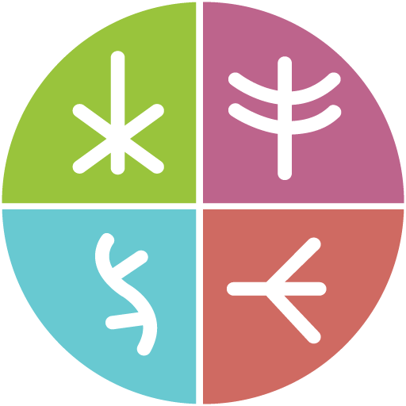

Call for participants
Together There
A residency on digital justice in arts and culture
Extended deadline: Oct 17, 2022
D/deaf and other disabled deadline: Oct 24, 2022

Contents
What is the Together There Residency? 2
Who are we looking for? 2
When is the residency? 3
How much will I be paid? 3
How will the residency meetings happen? 3
What will access and care be like in the residency? 3
How do I get more information? 4
When should I apply? 4
How do I apply? 4

What is the Together There Residency?
The residency is an opportunity to:
- Creatively explore digital justice in the arts and culture in Canada.
- Think about how technology, the internet, and data could be used to build a better future for everyone.
- Connect with other people exploring digital justice in the arts and culture in Canada.
- Showcase your work. We do not expect you to share completed work in the residency. We do expect you to document and share your process.

Who are we looking for?
To apply for the residency, you need to be:
- A resident of Canada who is 18 years of age or more
- Self-identify as Indigenous, Racialized, Disabled, or live Outside the core (in a suburban, rural, or remote community outside of the big city).
  - If you belong to one or more of these groups, we encourage you to apply.
  - If you belong to any of these groups plus other equity-seeking groups we also encourage you to apply.
  - Examples of other equity-seeking groups include 2SLGBTQIA+, Women, Youth, and New Canadians.
- Open to emerging, mid-career, established, and elder professionals from any discipline in arts and culture
- You do not need to know a lot about digital justice. The purpose of this residency is to help you learn about digital justice in arts and culture.

When is the residency?
The residency takes place between Nov 7, 2022 and Feb 24, 2023 (new dates). You will need to spend 80 hours on the residency. That is about 5 hours each week.
The residency includes mandatory group meetings plus individual check-in meetings with the residency support team. There will also be optional meetings with experts in digital justice. A full schedule with activity descriptions is available here.

How much will I be paid?
You will receive a $4,500 fee. There is also $1,000 more if you need to buy supplies or materials to help you share your work.

How will the residency meetings happen?
The residency will take place in English through online platforms like Zoom. We can offer CART captioning and ASL live interpretation during meetings, as well as English to French translations of meeting notes and reports. We may also use other online platforms, videos, audio and written notes, text, postal mail or radio.
If you need to pay for internet or a device to take part in this residency, you can use the $1,000 materials fee.

What will access and care be like in the residency?
Please let us know any access needs you have. We want to make sure you can take part in the residency. We also know that access can evolve. Please let us know if your access needs change during the residency. We know that we will also need to care for each other. We will build a set of values together that everyone in the residency will act in agreement with.

How do I get more information?
Multiple information sessions are planned via Zoom, YouTube and Facebook Live on September 29, October 5, 12, and 13 at 6 pm Eastern. For more information, visit https://togetherthere.ca/events or contact the residency team at hello@togetherthere.ca.

When should I apply?
The deadline to apply is Oct 17, 2022. D/deaf and other disabled people may apply until Oct 24, 2022. If we think you would be a good fit for the residency, we may ask you to an interview between Oct 17 to 28, 2022. We will let you know if your application was successful by Oct 31, 2022.

How do I apply?
Submit your application here: https://togetherthere.ca/residency-apply
Applicant responses may be submitted in any of the following formats in English, French, ASL, or LSQ:
- Written text, point-form acceptable
- Video format
- Audio format
If these ways of applying are not accessible, you can also talk to someone from Together There for 30 minutes. They will ask you the applications questions and you can talk about your answers. Schedule a talk by telephone or video call by writing care@togetherthere.ca.
We look forward to receiving your application!

