
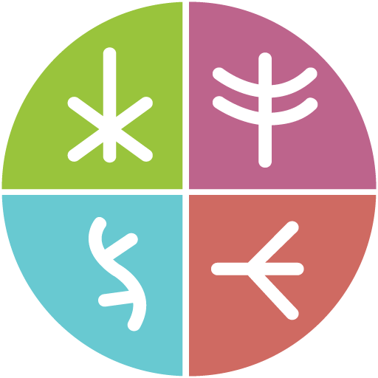
Principles of knowledge
Together There Residency

November 2022
Original language version

Knowledge seeking
What does it mean to be in relationship with the vibrant, evolving worlds of knowledge and information we find ourselves a part of? How might we create a regenerative, life-affirming, and sacred relationship to our shared ecologies? How are we honouring the living wisdom contained in all organisms, both seen and unseen?
In a most expansive sense, knowledge processes—from knowledge seeking and sensemaking to knowledge stewardship— can be understood as the journey of bringing visible and non-visible perspectives, ideas, and experiences into being. All organisms within our shared ecosystems carry information and have the potential to be powerful sources of knowledge that can enrich our understanding of our shared world across time and space.
Within the many histories and cultures of the world, knowledge has been understood, nurtured, produced, synthesized and valued in different ways. In ruling and dominant cultures, we have long experienced the consequences of approaches to knowledge processes that undertake a dominating, hierarchical, and capitalist lens. These knowledge processes are largely extractive, exploitative, and harmful for all beings on this planet who do not benefit directly from patriarchy, white supremacy, ableism, and heteronormativity.
The knowledge seeking practices and processes that we endeavour to explore, inspire, and empower throughout this residency are inherently grounded in decolonial, intersectional, and self-conscious points of view. Essentially, this means:
- We are invested in multiple, plural, and diverse alternatives to dominant or established forms of thinking, doing, and relating
- We center knowledge processes that are grounded in mutual respect and care for all life on this planet, and especially for those who continue to face systemic oppression, marginalization, and injustice
- We value lived and embodied experiences as sites of knowledge, thereby challenging normative dichotomies of mind-body, reason-emotion, and objective-subjective separation. We appreciate liminal spaces and feel them to be hives of wisdom
- We are interested in centering knowledge seeking processes that are culturally sensitive, community-driven, and self-reflexive
- We encourage knowledge seeking processes that are experimental, creative, thought-provoking, and out-of-the-box.

Knowledge stewarding
As knowledge stewards, we recognize that knowledge is not something to be dominated, it is something to be revered and cared for. The term stewardship is adopted from Indigenous “knowledge keeping” practices that to know anything is to “locate it in space and time and to consider it holistically as part of an overarching cosmic order in which individual persons, communities, all other animate and inanimate things, and even knowledge itself are interrelated” (Roberts and Wills, 2008). In this sense, knowledge stewards are the nurturers, gatherers and expanders of wisdom gardens, hives, trees, and reservoirs. Our role in this living web is to ensure that there is an ethic of care throughout all aspects of the knowledge building and sharing process. We are here to ensure that knowledge is held and shared in a conscious and balanced way, so that it is ultimately of value to communities who will then collectively hold, apply and build on the knowledge being shared.
Knowledge is the container that organizes the culture found within all organisms, which, by their very nature, both holds value and meaning in certain contexts and creates new contexts. The interdependent relationships we are refining between knowledge seeking and knowledge stewardship are inspired by a wide array of practices including Indigenous traditions. As a white-founded organization and an embodied ally of Indigenous and other equity-deserving communities, we respect the wisdom and rights of ownership of Indigenous communities to the language and practices of “knowledge keeping”. Applied researchers in academia and elsewhere have often adopted such language with little context, while we aim to ground the language we employ into a mysterious dyad between knowledge keeping and knowledge stewardship.
As we endeavour to cultivate a multi-modal, multi-disciplinary, and multi-dimensional knowledge hive throughout the Together There residency, we hope to activate knowledge processes that revitalize our sense of aliveness as creatures of, and participants in, this animate Earth, and so that our sense of renewal might influence our actions towards greater care in and beyond digital worlds.

Three pillars of knowledge stewardship
As knowledge stewards in Together There, we recognize that knowledge is a central, critical, and strategic tool for both understanding and critically examining digital realities as we are experiencing them in order to envision and eventually catalyze transformational change. The knowledge we are hoping to generate and share through this residency has the potential to meaningfully impact communities throughout Canada, especially equity-seeking communities who have been disproportionately negatively impacted by digital technologies and infrastructure. For the knowledge that we steward to have a positive, meaningful, and lasting impact on the world, we want to approach this responsibility with care, intention, and attentiveness.
This is why we have three guiding principles for knowledge stewardship that encompass the foundational principles we hope to abide by and integrate into our knowledge stewardship process.

Human-centered design
A human-centered approach to knowledge stewardship prioritizes the multiplicity of human beings and diverse communities, including their lived experiences, embodied wisdoms, pain points and collective dreams. By centering and therefore empowering the diverse perspectives, needs, values and goals of communities who may be impacted by knowledge outcomes, we are able to meaningfully co-create, co-vision and co-build the just futures we seek to inhabit.
Knowledge stewardship in this sense is a deeply integrative, explorative, creative, and imaginative process that is grounded in accountability, reflexivity, care, and accessibility.

Mindful, ethical, and conscious
For collaborative knowledge stewardship processes to positively impact communities and catalyze meaningful collective action, it is our responsibility to ensure that research-creative processes are mindful, ethical, and conscious.
Self and collective reflexivity is the foundational principle from which everything generates. Self-reflexivity is in essence the process of self-inquiring on our intentions, roles and responsibilities as knowledge stewards in order to reduce any harms or risks associated with knowledge production, including breaches of consent, privacy, confidentiality, and respect. From this place of mindfulness, we are able to ensure ethical processes of knowledge stewardship, including obtaining informed consent from research participants, ensuring ethical citation practices, and upholding privacy and confidentiality standards.

Intersectional
Finally, when adopting an intersectional lens into our knowledge stewardship process, we are recognizing the importance of the following:
- The interconnection between gender, race, class, and other categories of difference in our individual lives, social norms, institutional systems, and cultural ideologies
- The relationship between these interconnections, especially with respect to the ways we navigate power relations
- The ways in which equity-seeking groups often face multiple and intersecting forms of structural discrimination, oppression, violence, and trauma
- Cultivating a deeper awareness of nuance, complexity, and the value of a “both/and” perspective
To bring it full circle, we believe that knowledge, when leveraged mindfully, ethically, and consciously, and when grounded in intersectionality, has the potential to create deep and lasting change, only when it is done together with those most affected by its outcomes.




