Together There Residency
Journey Maps
November 2022
Original language version
Optimized for screens (1920 x 1080p)
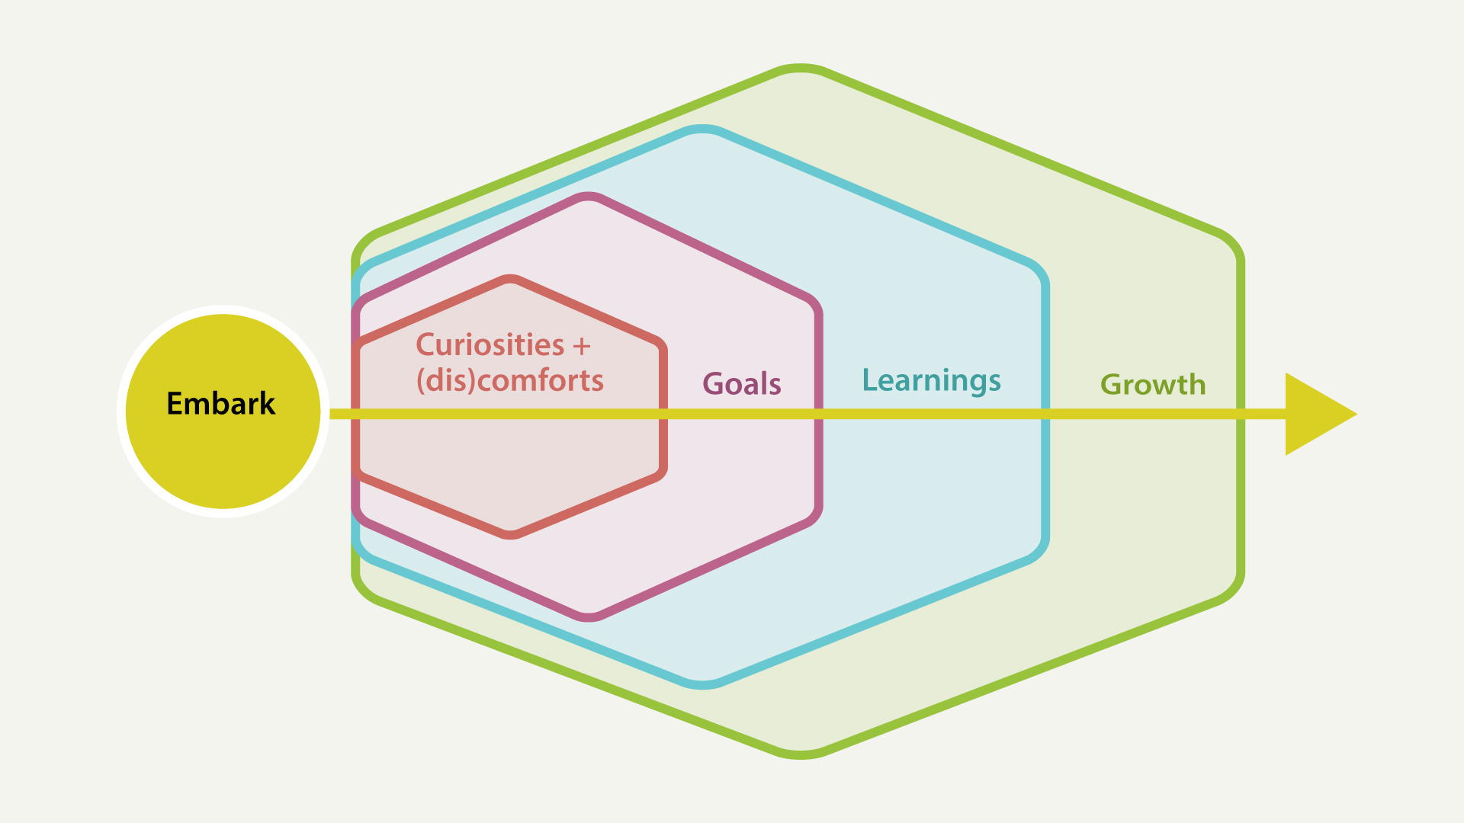
Journey Map #1: Preparing
Pre-residency reflections

Journey Map #1: Preparing

Embark
As I prepare to embark on my residency journey:
Where have I been? What people and experiences have helped bring me to here? What do I want to remember and carry forward with me (or, let go of)?

Curiosities + (dis)comforts
In the present moment (related to digital or social justice issues, topics, mediums, tools, processes, etcetera):
What am I curious about? What feels comfortable? Uncomfortable? What am I at the edges of?

Goals
In the short-term (during the residency period):
What are my wildest hopes and dreams for the residency? What would I be happy with? What am I wanting to explore? What am I grasping for? What am I hoping to uncover?

Learnings
In the middle-term (during and after the residency period):
What do I hope to learn about myself and my community? What kinds of digital tools or skills would you like to begin to learn?

Growth
As a result of your participation in the residency (long-term or open timelines):
How do I hope to grow in my own life? How do I hope to grow my support of the community? What wisdoms do I hope to cultivate? How will things be different? What potential barriers might impede my journey?

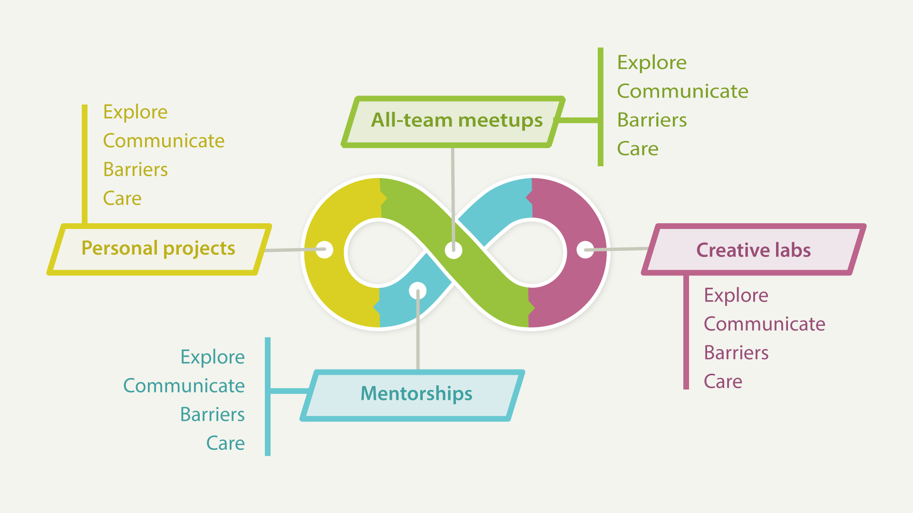
Journey Map #2: Committing
Resident responsibilities

Journey Map #2: Committing
There are four types of residency activities, including: all-team meetings, creative labs, mentorships with the residency care team and external experts, and personal projects. For each activity, please describe as you are able:

All-team meetings

Explore
What do you like to explore during this activity?
For example: What do you want to learn? How do you hope to benefit from participating?

Communicate
How would you like to communicate during this activity?
For example: What do you want to do? What kinds of topics are you ready to discuss? What methods of digital or lo-fi communication would you like to use (i.e., individual reflection, small group discussion, storytelling, games or role-playing, co-creating ideas or artwork in collaboration with others, whiteboards, email, texting, chats, postal mail, etcetera)?

Barriers
What barriers might I experience during this activity?
For example: What gaps or challenges might prevent you from fully participating?

Care
What does giving or receiving care look like during this activity?
For example: What steps am I ready to take for self-care? What steps am I ready to give care to others during the residency? What needs do I have in order to give or receive care or self-care?

Creative labs

Explore

Communicate

Barriers

Care

Mentorships

Explore

Communicate

Barriers

Care

Personal projects

Explore

Communicate

Barriers

Care

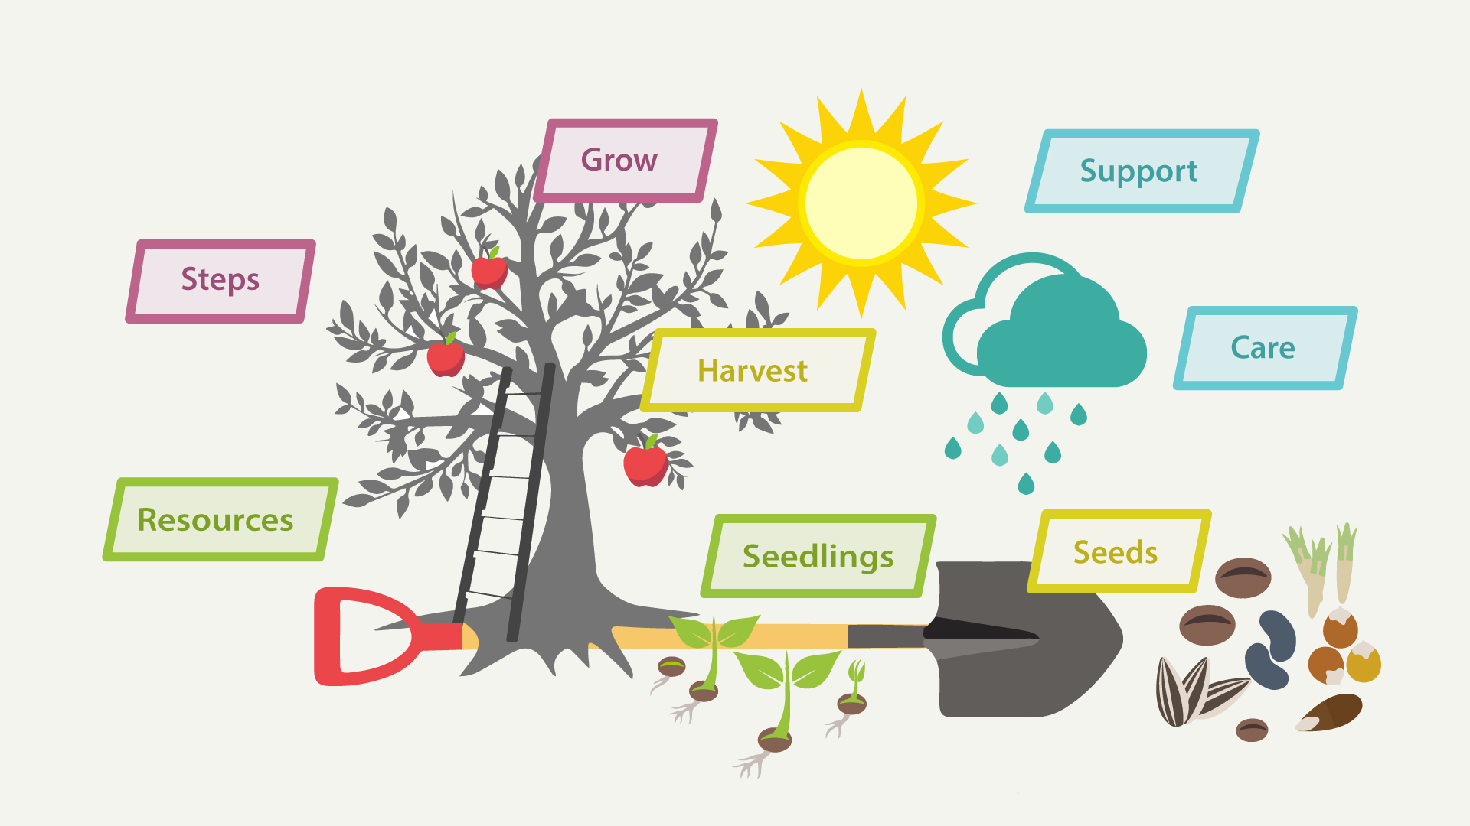
Journey Map #3: Harvesting
Knowledge harvesting

Journey Map #3: Harvesting

Harvest
What do I want to harvest?

Seedlings
What are the new seedlings that are emerging?

Seeds
As my journey evolves, what are the seeds that I am holding onto for the future?

Resources
What are my key resources to help me on my journey?

Steps
What steps can I take to grow my harvest?

Grow
What is my ideal environment for growth?

Support
How do I want to be supported through roadblocks?

Care
What are my needs on cloudy days?

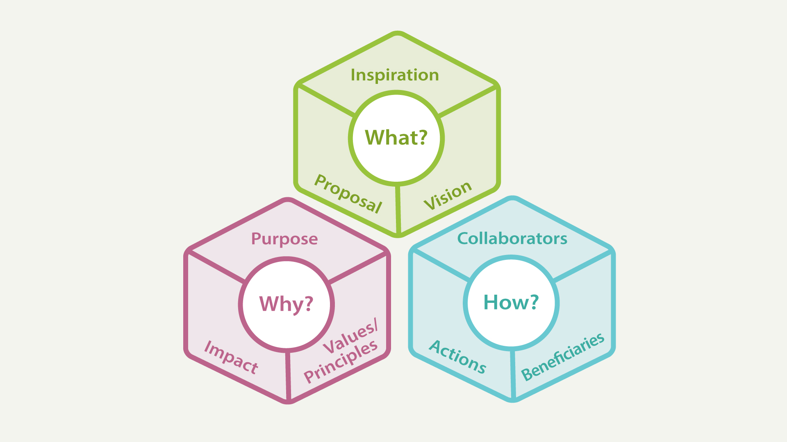
Journey Map #4: Shaping
Knowledge shaping

Journey Map #4: Shaping

What
- Inspiration: What are the sources of inspiration for your digital justice project?
- Proposal: What is your proposed digital justice project? An overall summary.
- Vision: What is the vision for your proposed digital justice project?

Why
- Purpose: What are the goals for your digital justice project?
- Impact: What is your theory of change for your digital justice project?
- Values / Principles: What values or principles help guide your digital justice project?

How
- Collaborators: Who is supporting or working with you on your digital justice project?
- Actions: Describe the types of activities or resources your digital justice project will produce or focus on.
- Beneficiaries: Who are the intended beneficiaries of your digital justice project?
Journey Map #5: Impacting
Personal impact
Make your own map to show your desired personal impacts post-residency.
What will be different as a result of your participation in the residency?

