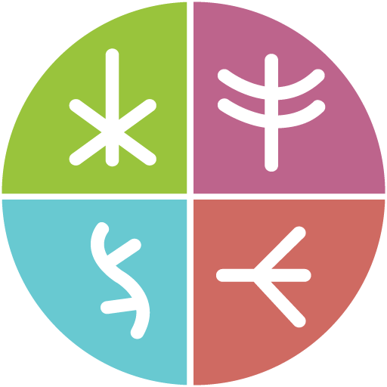

**Together There Residency**

Journey Map #5: Impacting

November 2022

Original language version

Optimized for screens (1920 x 1080p)

**Journey Map #5: Impacting  
Personal impact**

*Make your own map to show your desired personal impacts post-residency.   
What will be different as a result of your participation in the residency?*

