Together There Residency
Journey Map #4: Shaping
November 2022
Original language version
Optimized for screens (1920 x 1080p)
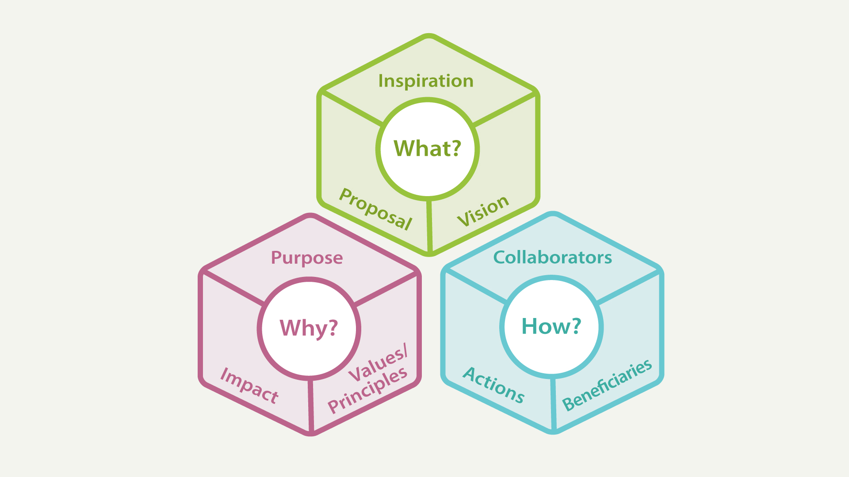
Journey Map #4: Shaping
Knowledge shaping

Journey Map #4: Shaping

What
- Inspiration: What are the sources of inspiration for your digital justice project?
- Proposal: What is your proposed digital justice project? An overall summary.
- Vision: What is the vision for your proposed digital justice project?

Why
- Purpose: What are the goals for your digital justice project?
- Impact: What is your theory of change for your digital justice project?
- Values / Principles: What values or principles help guide your digital justice project?

How
- Collaborators: Who is supporting or working with you on your digital justice project?
- Actions: Describe the types of activities or resources your digital justice project will produce or focus on.
- Beneficiaries: Who are the intended beneficiaries of your digital justice project?

