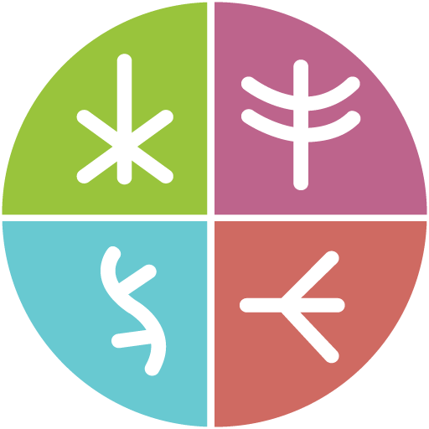
Together There Residency
Journey Map #3: Harvesting
November 2022
Original language version
Optimized for screens (1920 x 1080p)
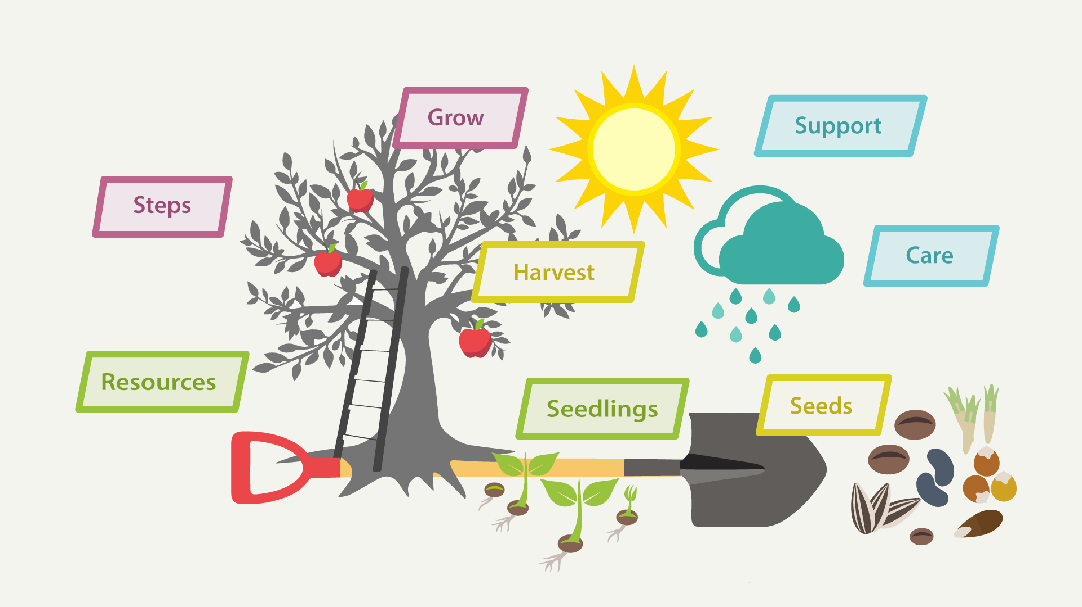
Journey Map #3: Harvesting
Knowledge harvesting

Journey Map #3: Harvesting

Harvest
What do I want to harvest?

Seedlings
What are the new seedlings that are emerging?

Seeds
As my journey evolves, what are the seeds that I am holding onto for the future?

Resources
What are my key resources to help me on my journey?

Steps
What steps can I take to grow my harvest?

Grow
What is my ideal environment for growth?

Support
How do I want to be supported through roadblocks?

Care
What are my needs on cloudy days?

