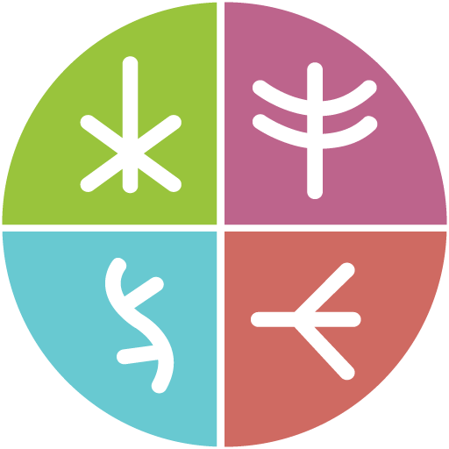
Together There Residency
Journey Map #2: Committing
November 2022
Original language version
Optimized for screens (1920 x 1080p)
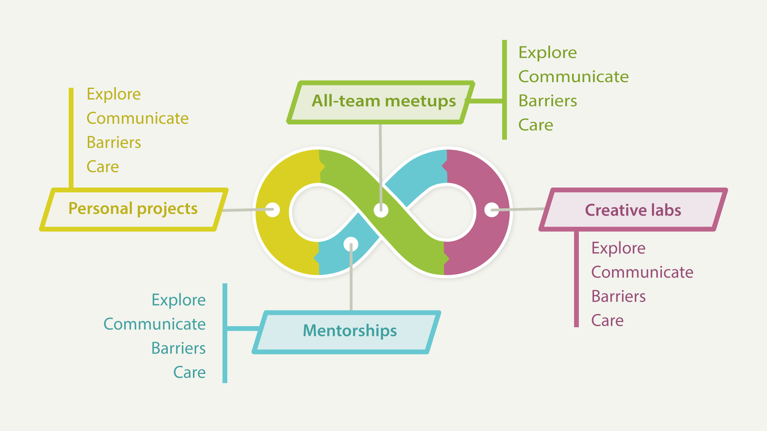
Journey Map #2: Committing
Resident responsibilities

Journey Map #2: Committing
There are four types of residency activities, including: all-team meetings, creative labs, mentorships with the residency care team and external experts, and personal projects. For each activity, please describe as you are able:

All-team meetings

Explore
What do you like to explore during this activity?
For example: What do you want to learn? How do you hope to benefit from participating?

Communicate
How would you like to communicate during this activity?
For example: What do you want to do? What kinds of topics are you ready to discuss? What methods of digital or lo-fi communication would you like to use (i.e., individual reflection, small group discussion, storytelling, games or role-playing, co-creating ideas or artwork in collaboration with others, whiteboards, email, texting, chats, postal mail, etcetera)?

Barriers
What barriers might I experience during this activity?
For example: What gaps or challenges might prevent you from fully participating?

Care
What does giving or receiving care look like during this activity?
For example: What steps am I ready to take for self-care? What steps am I ready to give care to others during the residency? What needs do I have in order to give or receive care or self-care?

Creative labs

Explore

Communicate

Barriers

Care

Mentorships

Explore

Communicate

Barriers

Care

Personal projects

Explore

Communicate

Barriers

Care

