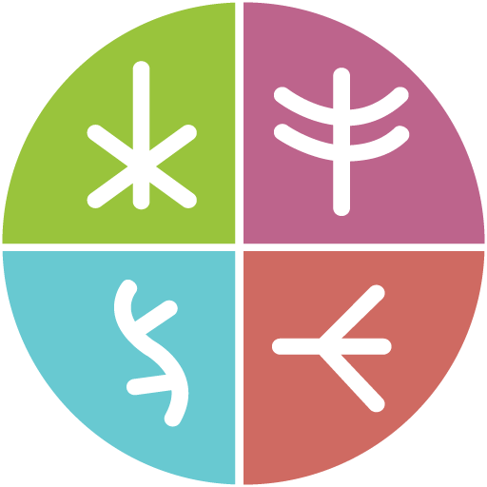
Together There Residency
Journey Map #1: Preparing
November 2022
Original language version
Optimized for screens (1920 x 1080p)
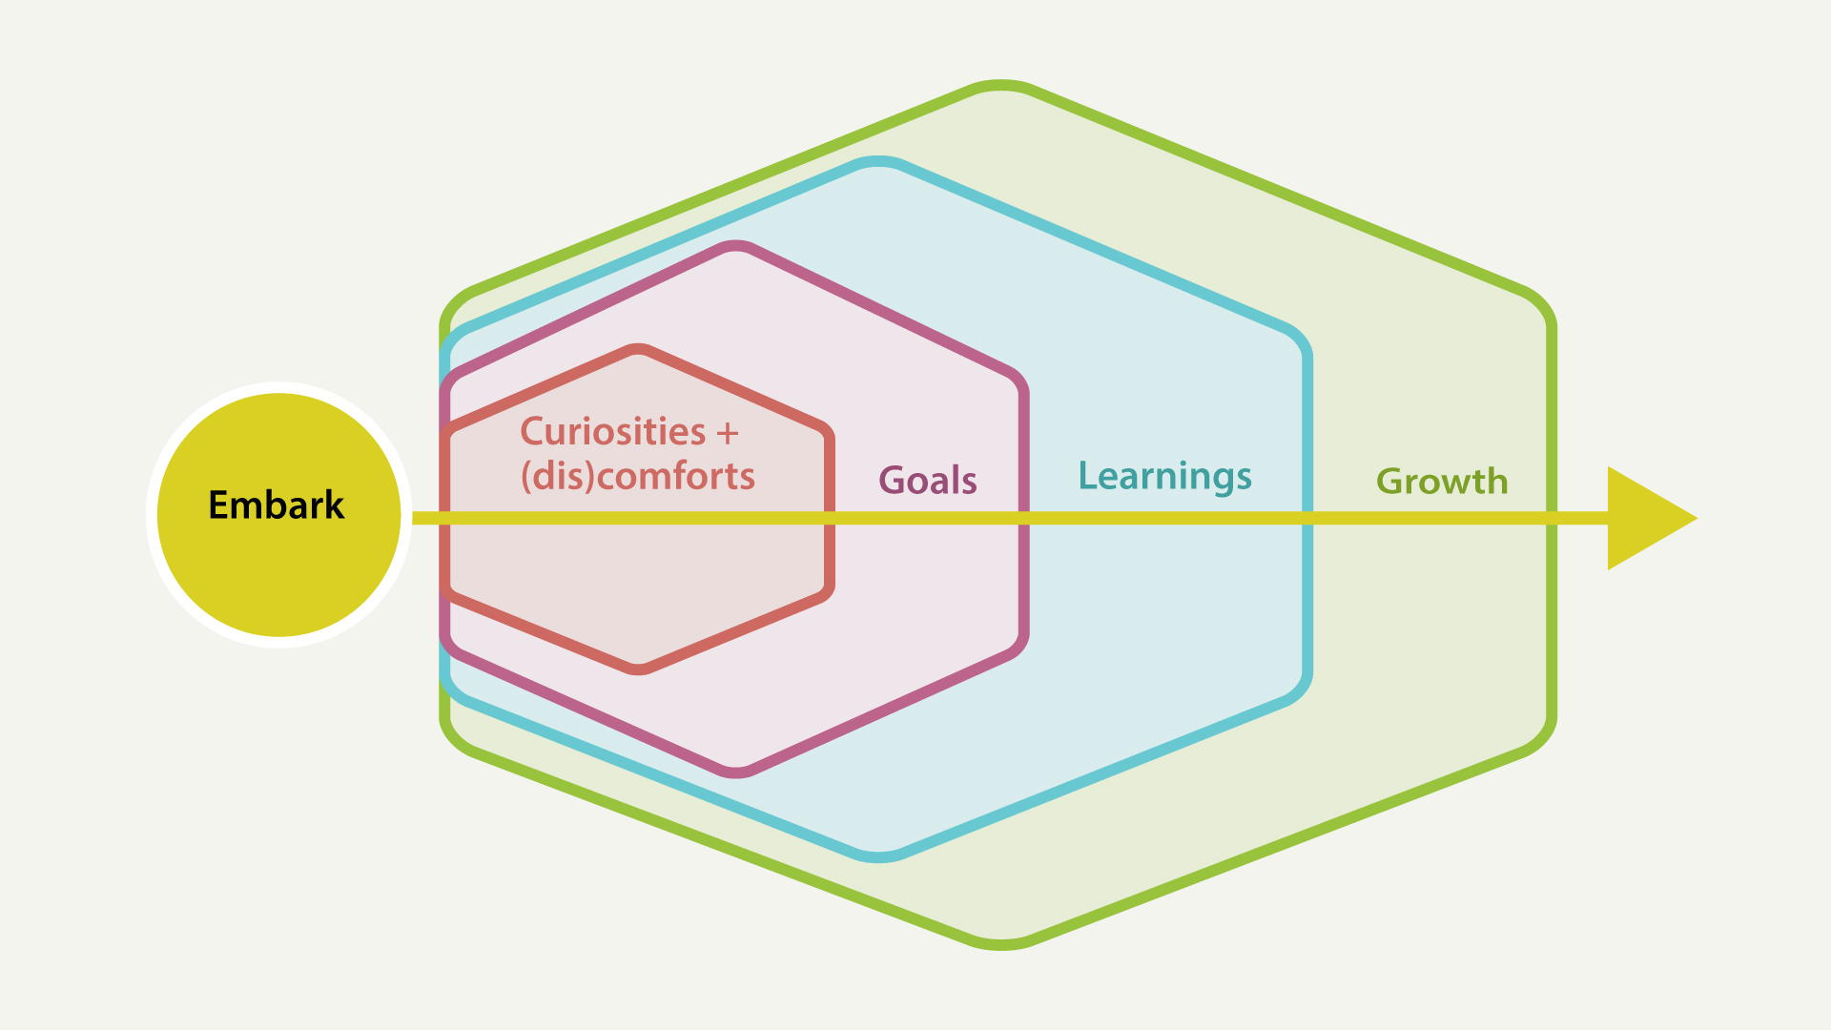
Journey Map #1: Preparing
Pre-residency reflections

Journey Map #1: Preparing

Embark
As I prepare to embark on my residency journey:
Where have I been? What people and experiences have helped bring me to here? What do I want to remember and carry forward with me (or, let go of)?

Curiosities + (dis)comforts
In the present moment (related to digital or social justice issues, topics, mediums, tools, processes, etcetera):
What am I curious about? What feels comfortable? Uncomfortable? What am I at the edges of?

Goals
In the short-term (during the residency period):
What are my wildest hopes and dreams for the residency? What would I be happy with? What am I wanting to explore? What am I grasping for? What am I hoping to uncover?

Learnings
In the middle-term (during and after the residency period):
What do I hope to learn about myself and my community? What kinds of digital tools or skills would you like to begin to learn?

Growth
As a result of your participation in the residency (long-term or open timelines):
How do I hope to grow in my own life? How do I hope to grow my support of the community? What wisdoms do I hope to cultivate? How will things be different? What potential barriers might impede my journey?

